PIZZA SALES SQL QUERIES
A. KPI’s
1. Total Revenue:
SELECT SUM(total_price) AS Total_Revenue FROM pizza_sales;
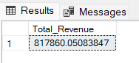
2. Average Order Value
SELECT (SUM(total_price) / COUNT(DISTINCT order_id)) AS Avg_order_Value FROM pizza_sales
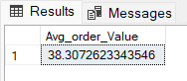
3. Total Pizzas Sold
SELECT SUM(quantity) AS Total_pizza_sold FROM pizza_sales
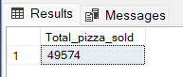
4. Total Orders
SELECT COUNT(DISTINCT order_id) AS Total_Orders FROM pizza_sales
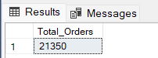

5. Average Pizzas Per Order
SELECT CAST(CAST(SUM(quantity) AS DECIMAL(10,2)) /
CAST(COUNT(DISTINCT order_id) AS DECIMAL(10,2)) AS DECIMAL(10,2))
AS Avg_Pizzas_per_order
FROM pizza_sales
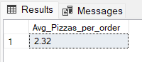
B. Daily Trend for Total Orders
SELECT DATENAME(DW, order_date) AS order_day, COUNT(DISTINCT order_id) AS total_orders
FROM pizza_sales
GROUP BY DATENAME(DW, order_date)
Output:
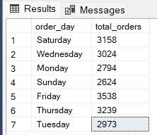

C. Hourly Trend for Orders
SELECT DATEPART(HOUR, order_time) as order_hours, COUNT(DISTINCT order_id) as total_orders
from pizza_sales
group by DATEPART(HOUR, order_time)
order by DATEPART(HOUR, order_time)
Output
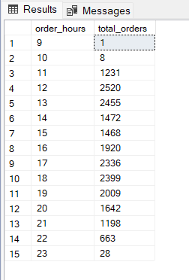

D. % of Sales by Pizza Category
SELECT pizza_category, CAST(SUM(total_price) AS DECIMAL(10,2)) as total_revenue,
CAST(SUM(total_price) * 100 / (SELECT SUM(total_price) from pizza_sales) AS DECIMAL(10,2)) AS PCT
FROM pizza_sales
GROUP BY pizza_category
Output
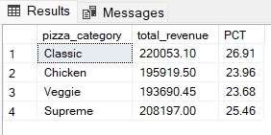

E. % of Sales by Pizza Size
SELECT pizza_size, CAST(SUM(total_price) AS DECIMAL(10,2)) as total_revenue,
CAST(SUM(total_price) * 100 / (SELECT SUM(total_price) from pizza_sales) AS DECIMAL(10,2)) AS PCT
FROM pizza_sales
GROUP BY pizza_size
ORDER BY pizza_size
—IF we want to see it for quarter base.
SELECT pizza_size, CAST(SUM(total_price) AS DECIMAL(10,2)) as total_revenue,
CAST(SUM(total_price) * 100 / (SELECT SUM(total_price) from pizza_sales Where DATEPART(quarter, order_date)=1)AS DECIMAL(10,2)) AS PCT
FROM pizza_sales
Where DATEPART(quarter, order_date)=1
GROUP BY pizza_size
ORDER BY PCT DESC

Output
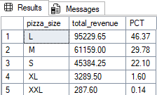

Quarter base output
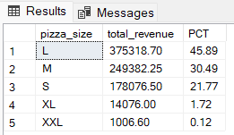
F. Total Pizzas Sold by Pizza Category
SELECT pizza_category, SUM(quantity) as Total_Pizza_Sold
FROM pizza_sales
GROUP BY pizza_category

Output
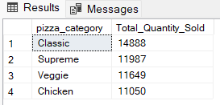

G. Top 5 Best Sellers by Total Pizzas Sold
SELECT Top 5 pizza_name, SUM(quantity) AS Total_Pizza_Sold
FROM pizza_sales
GROUP BY pizza_name
ORDER BY Total_Pizza_Sold DESC
Output
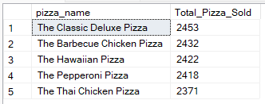

H. Bottom 5 Best Sellers by Total Pizzas Sold
SELECT TOP 5 pizza_name, SUM(quantity) AS Total_Pizza_Sold
FROM pizza_sales
GROUP BY pizza_name
ORDER BY Total_Pizza_Sold ASC
Output
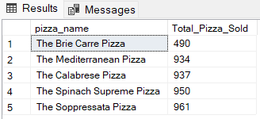

Or if we want to see by month wise then
SELECT TOP 5 pizza_name, SUM(quantity) AS Total_Pizza_Sold
FROM pizza_sales
WHERE MONTH (order_date)=1 — it will as a january month
GROUP BY pizza_name
ORDER BY Total_Pizza_Sold ASC

NOTE
If you want to apply the Month, Quarter, Week filters to the above queries you can use WHERE clause. Follow some of below examples
SELECT DATENAME(DW, order_date) AS order_day, COUNT(DISTINCT order_id) AS total_orders
FROM pizza_sales
WHERE MONTH(order_date) = 1
GROUP BY DATENAME(DW, order_date)

*Here MONTH(order_date) = 1 indicates that the output is for the month of January. MONTH(order_date) = 4 indicates output for Month of April.

SELECT DATENAME(DW, order_date) AS order_day, COUNT(DISTINCT order_id) AS total_orders
FROM pizza_sales
WHERE DATEPART(QUARTER, order_date) = 1
GROUP BY DATENAME(DW, order_date)

*Here DATEPART(QUARTER, order_date) = 1 indicates that the output is for the Quarter 1. MONTH(order_date) = 3 indicates output for Quarter 3.

